# **Title: Reflect**

1. **Genre:** Top-down 2-D Puzzle
2. **High Concept:** The game is a top-down 2-D puzzle game that tasks the player with navigating a set of hazardous puzzles. The task is augmented by the necessity of safely guiding the player’s reflection, which faces hazards different to those the character’s actual body faces. As the player navigates the different levels, the player will become less bound and restricted by his reflection, underlining the message that you should not limit yourself by dwelling on what you now are, but should strive to seek what you can become.
3. **Back Story:**

The story of the game centers around a face and his reflection. For a long time, the face felt very limited and unsure of what he was capable of. This self-doubt manifested itself in the haunting manner in which he viewed his own reflection in the mirror. Seeing his own reflection, he thought he saw obstacles that he was incapable of surpassing, which in turn prevented him from actually overcoming those obstacles in real life.

One night, as the face closed his eyes and drifted into deep slumber, he was visited by a terrible nightmare. Everywhere the face turned, the face saw a reflection of himself and was reminded of the perceived obstacles that he could not overcome. He found himself trapped in his own nightmare, unable to escape.

This is the story of how the face attempted to escape the dream and navigate his way through his own mental obstacles. On the way, the face will discover that, just as he imposed these obstacles on himself, he can take these obstacles away.

1. **Target and Platform:**

Target audience: Fans of puzzle games with intriguing narratives. Ages 10 and up.

Platform: Windows PC

1. **Game Play:**

The game will feature the mechanic of controlling yourself and your reflection at the same time. The reflection will prevent the player from advancing whenever the reflection encounters an obstacle such as a wall. The player character must find ways of making paths for the reflection to surpass those obstacles. Ultimately, the game is about getting from point A to point B, from the beginning of the level to the end.

1. **USP (Unique Selling Proposition):**  List up several selling points

* Unique gameplay
* Intriguing story and message
* Clever level design
* Tutorial that teaches game mechanics
* 5 levels

1. **Competitive Analysis:**

* **Sgt. Smiles: https://squatchworx.itch.io/sgt-smiles**

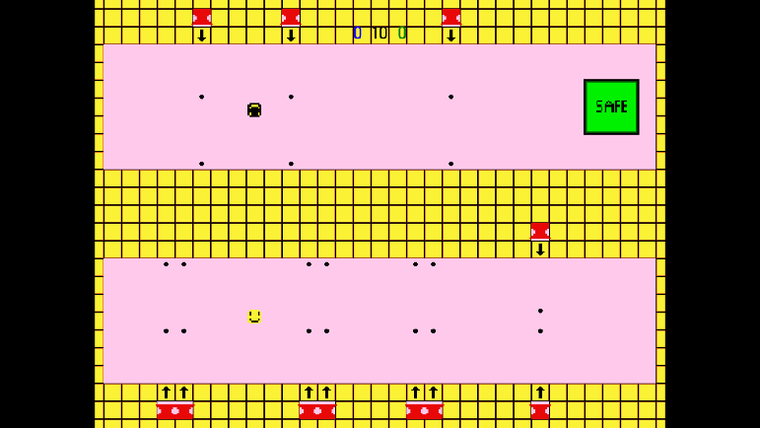

* **Through the Mirror: http://www.newgrounds.com/portal/view-insecure/644873**

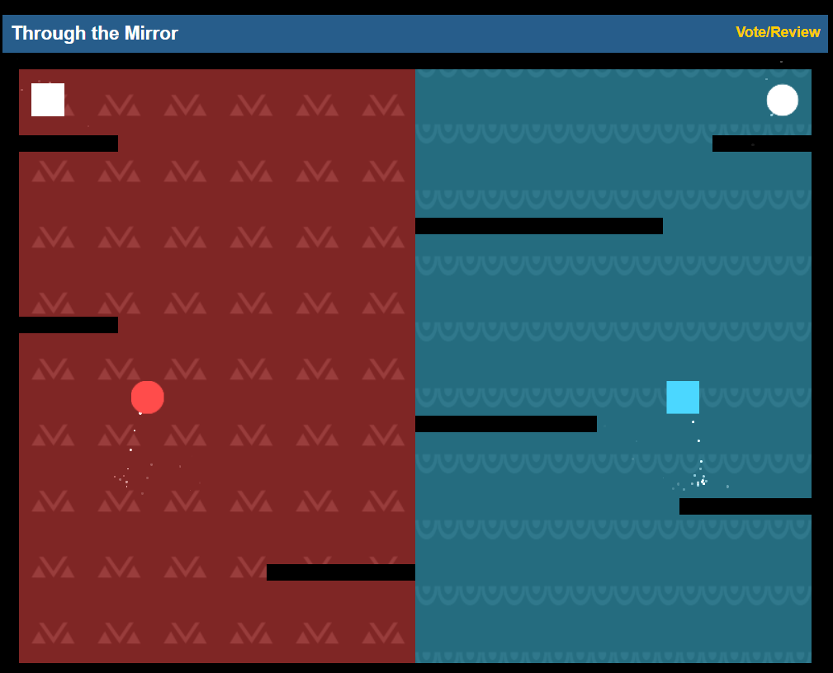

* **Mirror Runners 2 Ice:** [**https://www.newgrounds.com/portal/view/584878**](https://www.newgrounds.com/portal/view/584878)

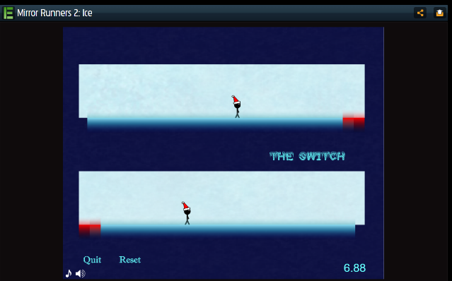

1. **Budget:**

**N/A**

1. **Members:**

**Name:** Jacob Hreshchyshyn

1. **Summary:**

Reflect will be a 2-D top-down puzzle game that features levels in which the player navigates from point A to point B. The player’s reflection hinders the player by obstacles it faces, thereby forcing the player character to help the reflection overcome these obstacles. There will be a tutorial and 5 levels. Narrative will be delivered throughout the game.

1. **Concept Arts:** Copy and Paste some sketches

